# Handy Helpful Hints for German Genealogy Researchers

Presented by Philip Mann to the Germanic and Continental Europe (GCE) Special Interest Group (SIG) of the South Australian Genealogy & Heraldry Society Inc (SAGHS) on 9 April 2025.

## Introduction

Tonight, I will discuss a number of tools I use to help my research into my European ancestors. I cannot cover everything and some of you will be familiar with all I mention. Your research would use other resources depending on your origins. I have added some suggestions from Ian Simon to the end of this paper.

In particular, I will be discussing:

* SAGHS Online databases;
* Trove;
* Transcription and translation;
* Google Translate;
* The snipping tool;
* WordMine;
* Meyers Gazetteer;
* Kartenmeister;
* a surname distribution map; and
* DNA testing.

## SAGHS Online Databases

The obvious first step is to work from the known to the unknown.

I know my parents were married on 1 October 1930 in South Australia.

Can I confirm this? SAGHS Online Database search currently shows:

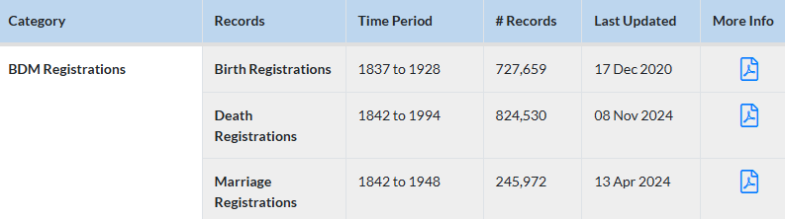

I entered my mother’s maiden name and it shows one birth registration and one marriage registration.

Let’s look at the marriage registration.

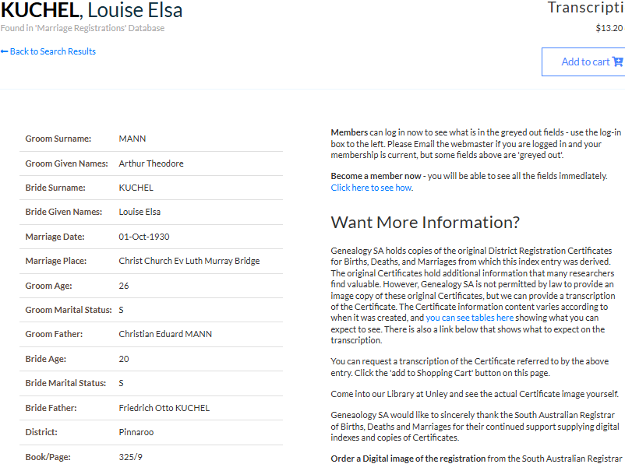

This confirms the date, but you cannot rely 100% on transcription.

Can we find more about this wedding? They were humble folk so I did not expect to find anything, but … Trove.

## Trove

What is Trove?

The Trove I love and use is a digitalised collection of Australian resources. Trove is a result of the collaborative effort of many different organisations, communities and individuals who work with the National Library to help make Australian content easier to find, share and use.



I inserted their surnames in the search engine and found:

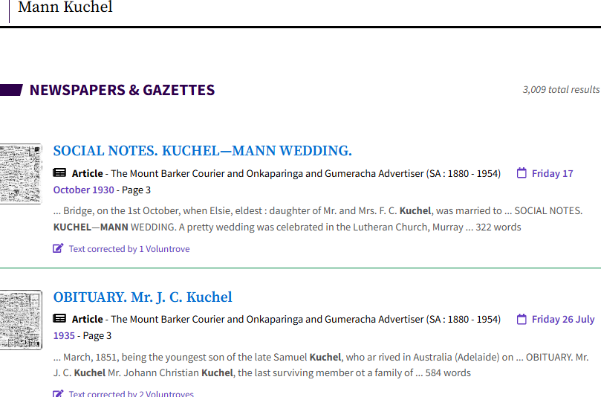

Wow! The first is my parent’s wedding, the second is my great grandfather’s obituary.

Click! And

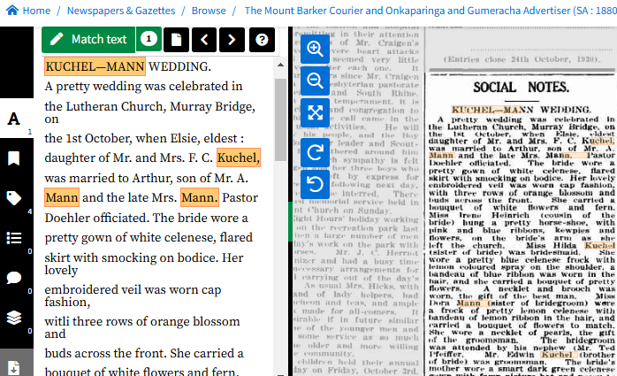

A couple of little problems showing newspapers were no more accurate then than they are today – I wonder whether the reports the papers were given were in German script. My grandfathers’ names were “Friedrich Otto Kuchel” and “Christian Eduard Mann” which would not be abbreviated to “F. C. Kuchel” and “A. Mann”.

The newspaper report has details that were not covered in the SAGHS transcription that are very useful in assisting your research.

Now, how do I keep a permanent record. Records online can move or disappear over time – always best to save items to your computer when you see them. See the download button.

Click it!

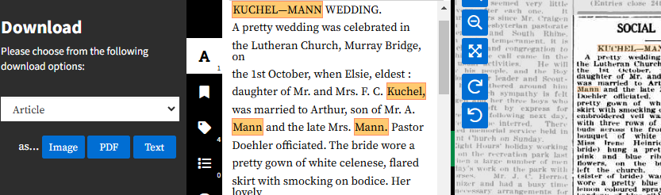

See the left hand side. I always choose pdf, others might like Image or Text. Eventually, this box settles.

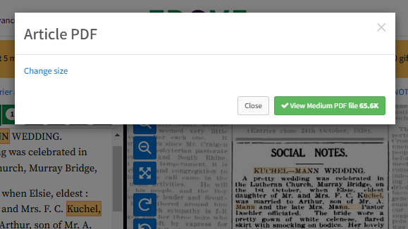

Click View Medium pdf file.

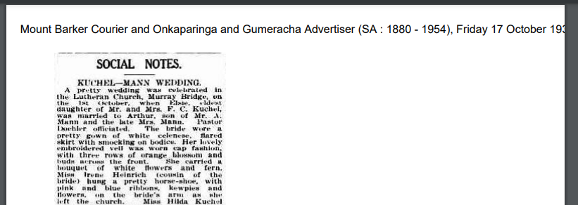

The paper details are at the top of the pdf file, the web address is at the bottom right.

Right click, save as. Wherever you want on your computer.

Back to my great grandfather’s obituary found in the original search.

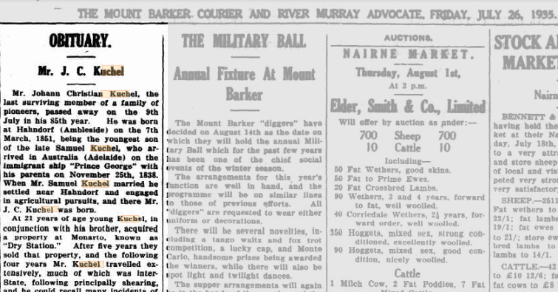

Trove also contains some newspapers printed in German.

Australische Zeitung of 2 December 1908 carried an advertisement for the auction of some of my great grandmother’s assets.

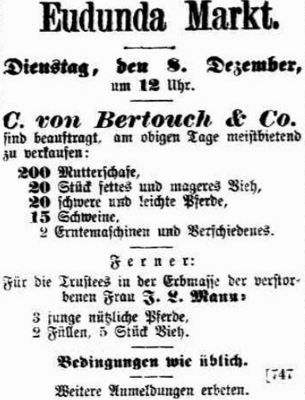

I don’t speak German so how do I make sense of it.

## Transcription and Translation

There are now a number of online options available to assist in translation of documents or text into English. 2 that I use are Google Translate (<https://translate.google.com.au/?sl=de&tl=en&op=translate>) and DeepL (<https://www.deepl.com/en/translator>). I am more used to Google Translate.

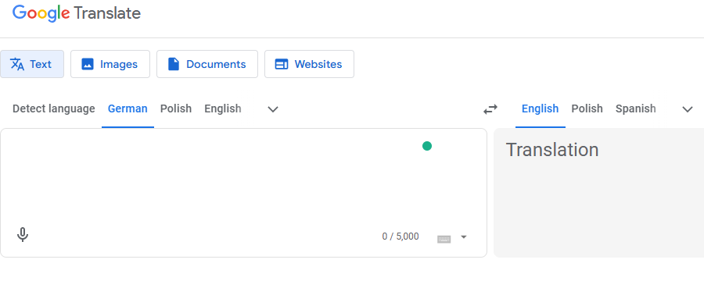

Note that 4 options are offered. I am familiar with and will demonstrate the first 2, text and image. Google Translate will detect the language being translated. I want it translated into English. I will use the snipping tool  and paste the image of the auction advertisement into the right hand box.

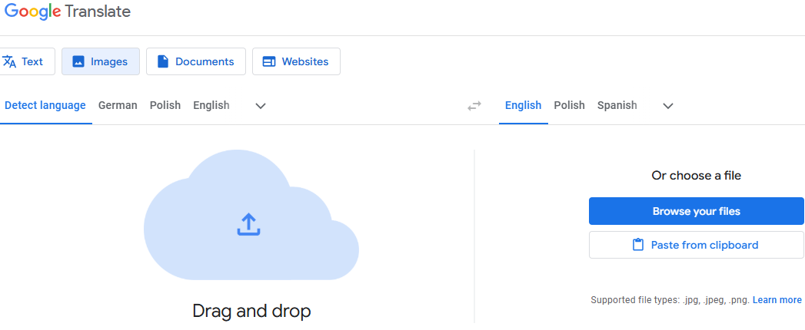

I will paste from the clipboard. The result is:

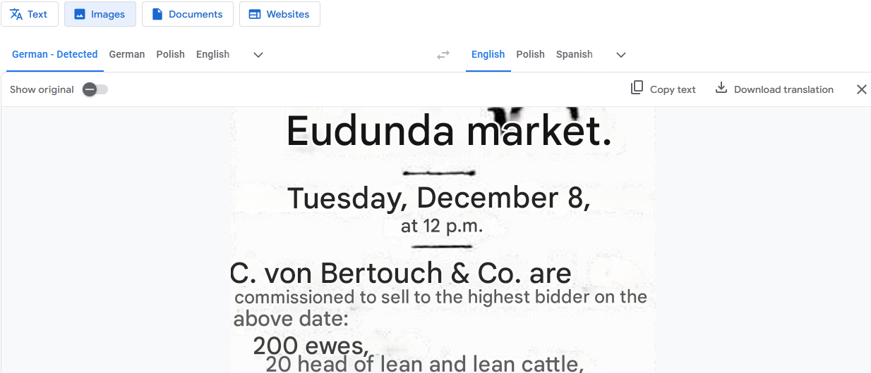

It is not perfect but it is not too bad.

Google Translate offers an alternative of translation from text.

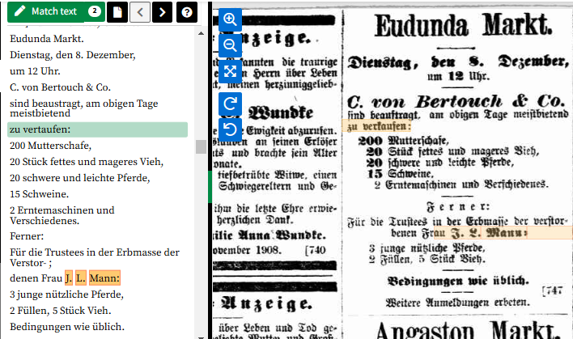

The text in newspapers on Trove is shown on the left hand side of the page.

After amending some of the text in Trove, I copied that text into the left hand side of the Google Translate page after depressing Text in the top left.

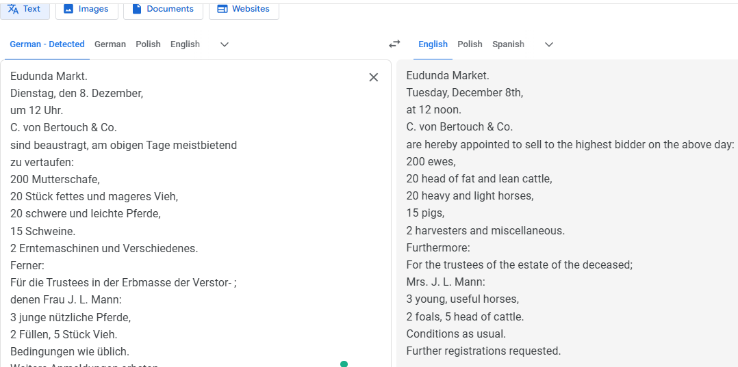

So how does Google Translate work on German script? My great grandfather’s baptismal record:

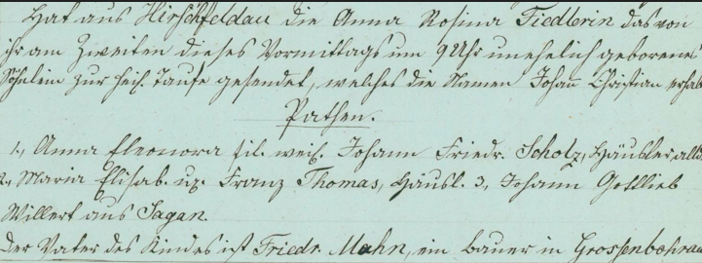

I pasted the image into Google Translate.

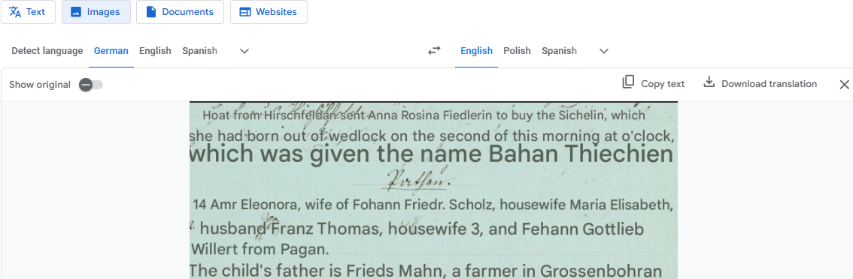

Not so good.

So try my own transcription.

In the second row, there appears . It starts with a “z” and ends “eiten” but what is between those letters?

## WordMine

I find WordMine (<https://www.wordmine.info/>) very useful.

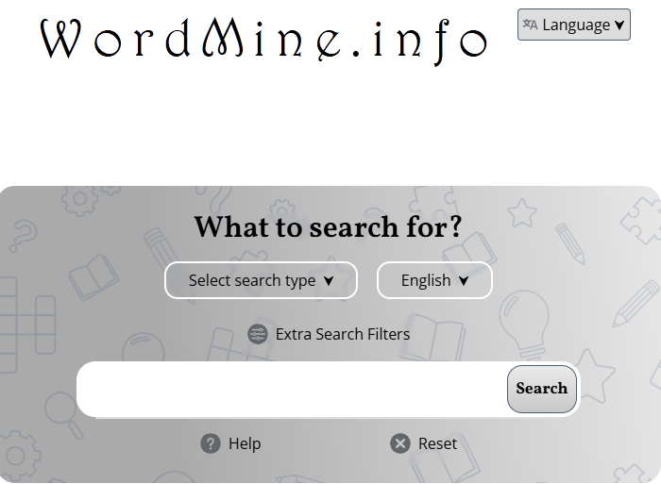

There is a large range of options available. For search type,

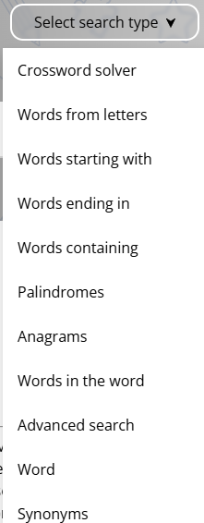

For language,

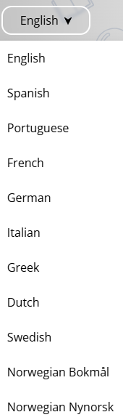and many more.

Extra filters allow a number of different options.

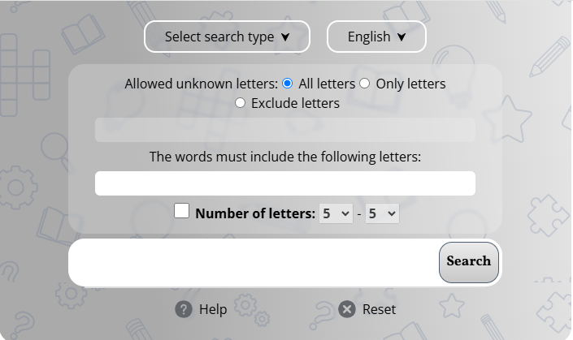

It starts with a “z” and ends “eiten” and would appear to have between 6 and 9 letters, but what is between those letters?

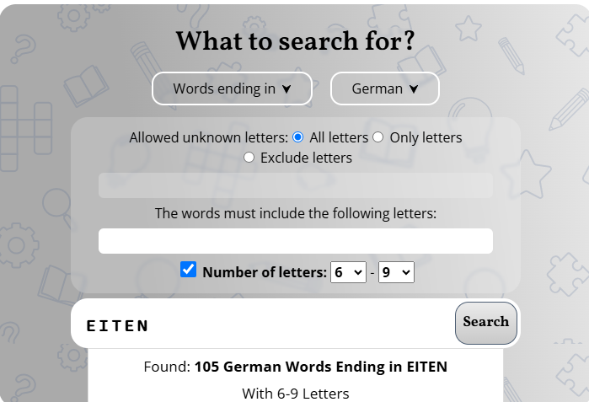

105 words is too many so add another filter.

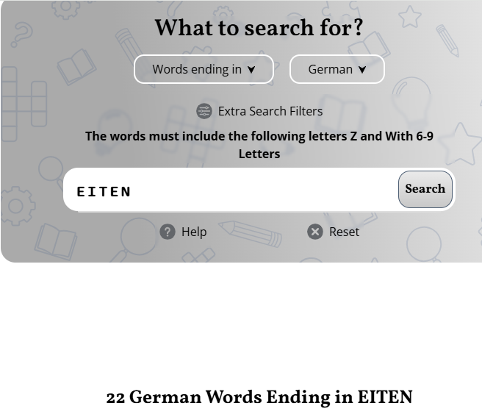

22 is more malleable.

Part of the list is shown below:

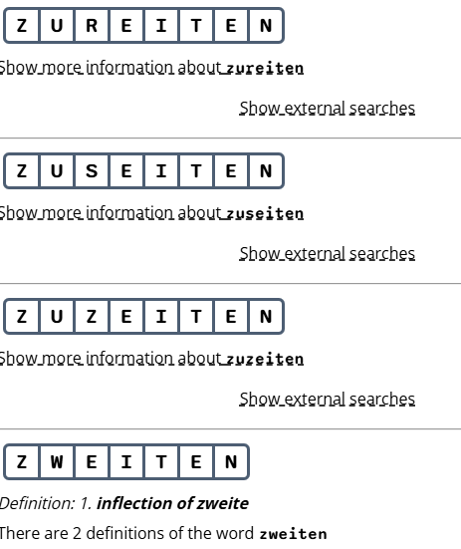

I then put my transcription into Google Translate and

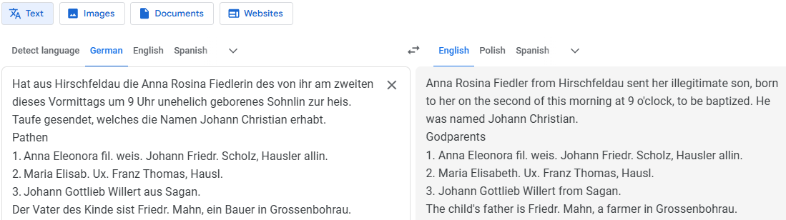

Still not perfect but getting better. It does not handle abbreviations or Latin words in the middle of German script too well. In the above, “fil. weis.” means “daughter of the deceased”, and “ux.” means “wife”. “Friedr.” is an abbreviation for “Friedrich”, “Hausler” is “cottager” and “Hausl.” is an abbreviation for “Hausler”.

I am advised that AI on my transcription will produce an even better result, but I am not sufficiently confident at this stage to show you how. However there are a number of webinars coming up on Legacy FamilyTree webinars (<https://familytreewebinars.com/webinar-library/>) which address that topic.

## Where is that village?

Most of us are unfamiliar with the European village our ancestors came from?

Thankfully there are online sources to assist.

Meyers Orts- und Verkehrs-lexikon des deutschen Reichs, otherwise known as Meyers Gazetteer is the most important of all German gazetteers. The goal of the Meyer’s compilers was to list every place name in the German Empire (1871-1918). It gives the location, i.e. the state and other jurisdictions, where the civil registry office was and Church parishes if that town had them. It also gives lots of other information about each place. The only drawback to Meyer’s is that if a town did not have a parish, it does not tell where the parish was, making reference to other works necessary.

I said earlier that my ggf Johann Christian Mann was born in Hirschfeldau.

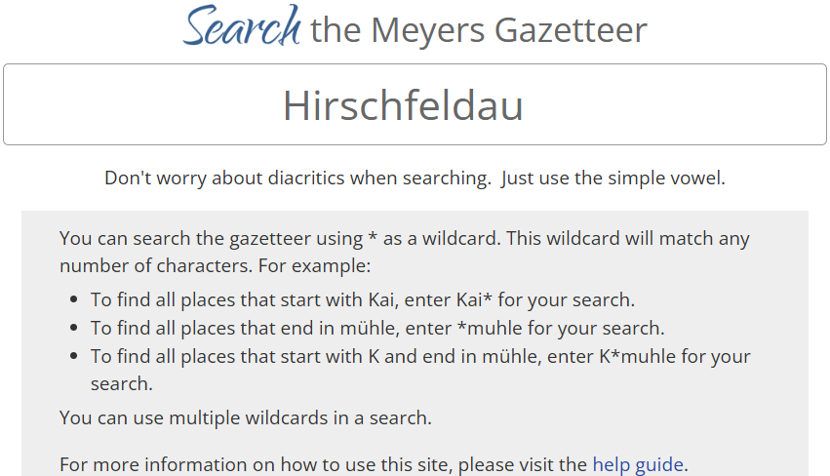

2 possible results come up.

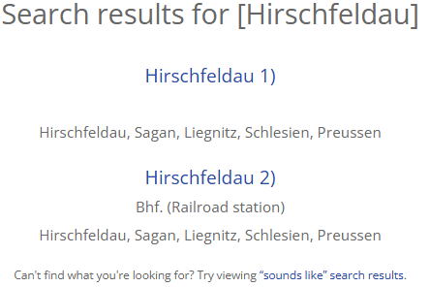

We will try the village not the railway station.

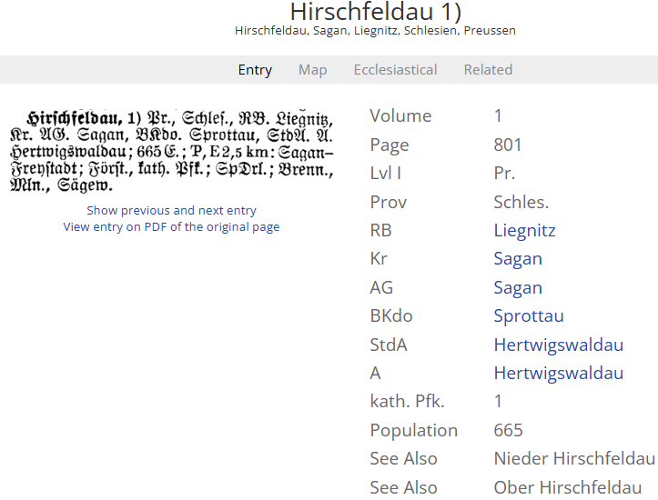

There are details further down on the page explaining what the abbreviated categories mean.

The map is not shown as there is no latitude or longitude information for this place. However this information is available for the railway station.

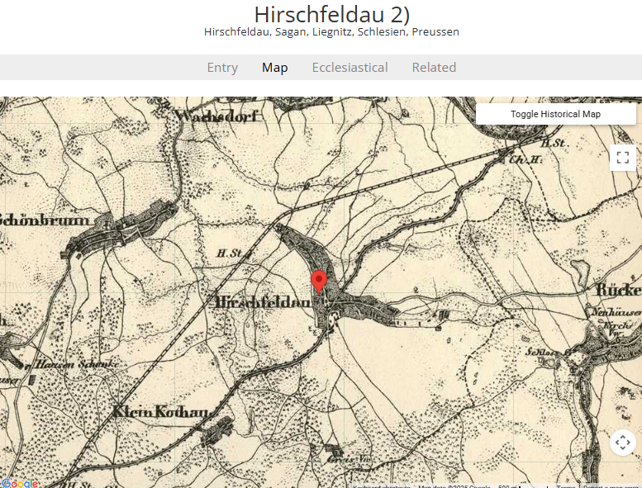

The distance the location is from nearby churches is shown:

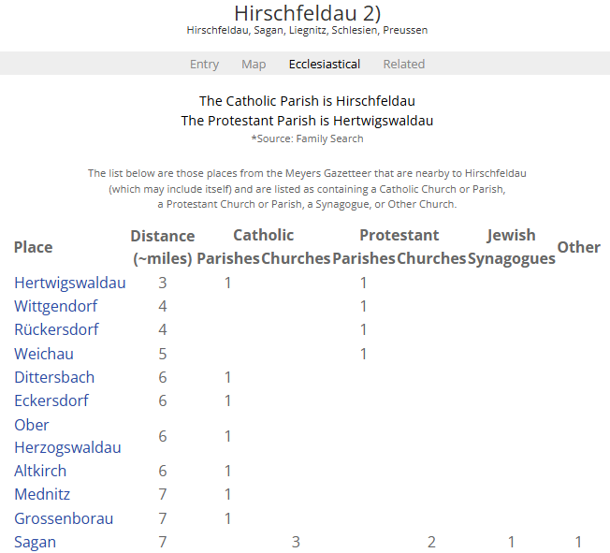

Kartenmeister offers itself as the most comprehensive database of its kind in the world. It contains 110,003 locations with over 45,115 name changes once, and 5,500 twice and more. All locations are east of the Oder and Neisse rivers and are based on the borders of the eastern provinces in Spring 1918. Included in this database are the following provinces: Eastprussia, including Memel, Westprussia, Brandenburg, Posen, Pomerania, and Silesia. It currently lists most towns or points. There are several ways or criteria to search.

* German name
* Older German name
* Kreis/County
* By the next larger town, (this is a proximity search.)
* Today's Polish, Russian or Lithuanian name.
* by Family Name

More explanation is included on the front page which will help in your searches.

Let’s see what information is there for Hirschfeldau.

Enter and submit are at the bottom of the entry page.

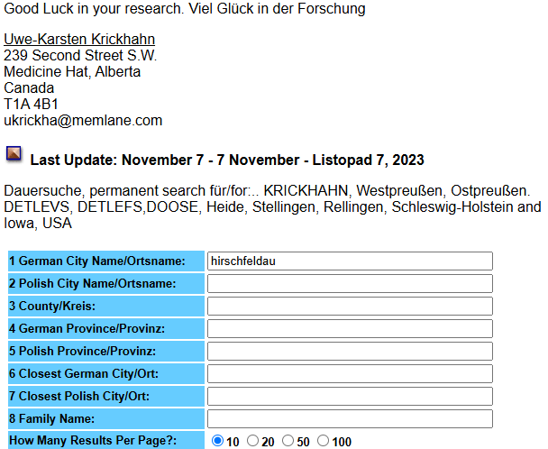

One record is found.

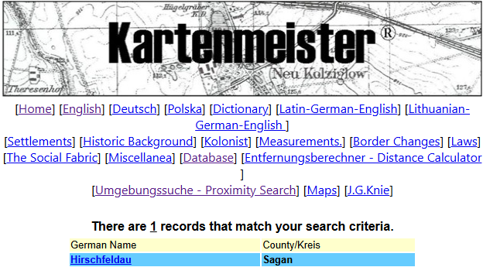

Considerable information is supplied, including today’s name and today’s province.

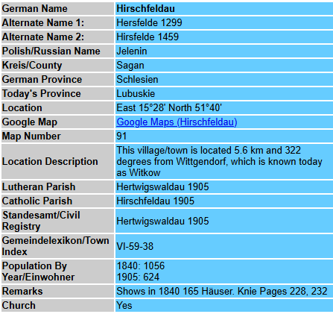

Information on the modern name and province can be googled. Many villages have websites with current and historical information and images. There are also websites showing historical and current images of the now-Polish villages at https://polska-org.pl/. Thanks, Ian Simon.

## Surname distribution

The interactive name distribution map can be used to show where a particular surname occurs most frequently. Data is sourced from

* German [casualty lists of World War I](https://wiki.genealogy.net/Verlustlisten_Erster_Weltkrieg); and
* [Telephone book](https://wiki.genealogy.net/Telefonbuch) CD from 1996

For each surname appearing in the casualty lists of the First World War, the soldiers' georeferenced hometowns are located on a map of the German Empire from 1914. Calculations show that the soldiers' average birth date is 1890—hence the first date for the name distribution. This can be compared with the distribution of surnames based on telephone directory data from 1996. The name distribution map illustrates the significant shifts, which are primarily a result of the Second World War.

The web application can be accessed at [https://nvk.genealogy.net](https://nvk.genealogy.net/)

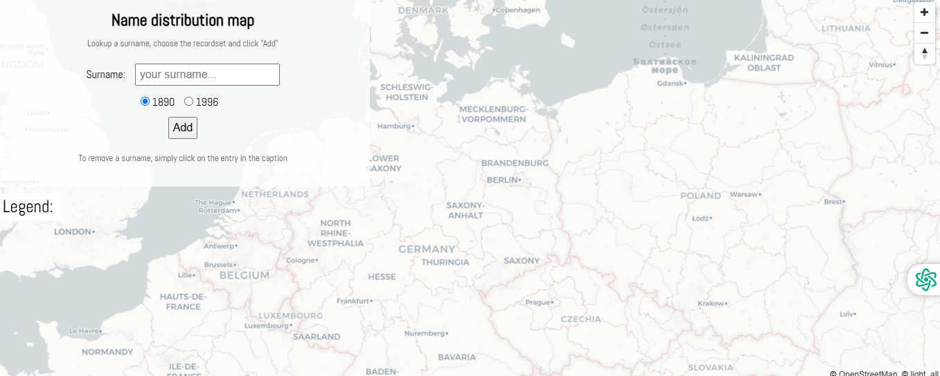

I use 1890 because it is closer in time to when my ancestors left the area.

My mother’s maiden name was Kuchel. According to familysearch.org, “Kuchel” is a habitational name from any of numerous minor placenames in Bavaria and the Tyrol that get their name from Köchel, a dialect term denoting an island of raised land surrounded by marsh, from Middle High German köche.

I tried other variations of the spelling of Kuchel but found that only “Kuchel” and “Köchel” were represented in Germany in 1890. The distribution of the names was most concentrated near Hamburg and in Schleswig-Holstein, and from Thuringia through Saxony to Silesia.

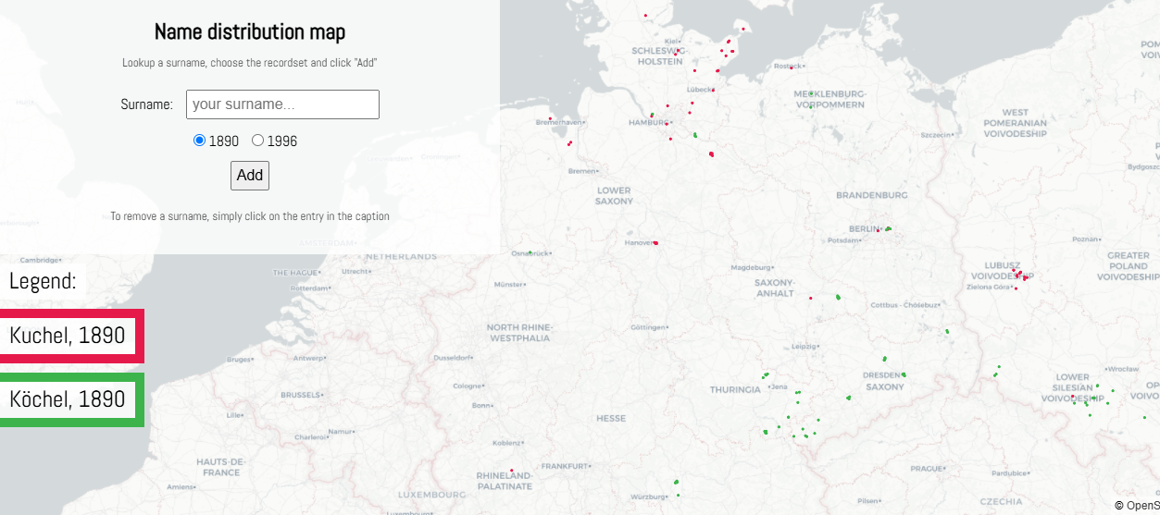

According to familysearch, their Family Tree contains 290 in Germany, 257 in Australia and 178 in the United States. So, proportionately, Kuchels are over-represented in Australia.

## DNA testing

I undertook DNA testing through Ancestry.com, which has the largest database of the DNA testing companies. I am currently not subscribing to Ancestry.com so currently I am not able to access a number of valuable resources on that site. However, they keep offering me hints to tempt me to resubscribe. And I will … eventually. Currently I am too busy sorting my MyHeritage matches so I don’t have sufficient time to look at Ancestry.com as well.

I have uploaded my results for free to the sites MyHeritage, Gedmatch and FamilyTreeDNA, thus getting many more matches. My personal experience is that my closer matches, largely in Australia, are concentrated in Ancestry and that MyHeritage supplies matches to my more distant relations, spread throughout the world and descendants of my German and Eastern European ancestors. The location of my DNA matches on MyHeritage is:

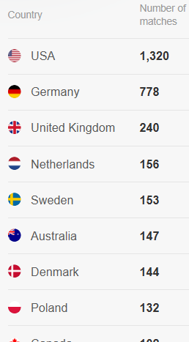

Further down, there are many interesting countries including Czechia with 71, Ukraine 40 and Brazil 10.

## Resources suggested by others

Ian Simon kindly suggested the point that other people's research would use other resources depending on their origins, and provided a list of other sites he regularly uses:

* openstreetmap - much clearer than Google maps, also includes house numbers – very useful in Poland.
* Polish postcards – he finds the best way is to go to a town he has researched and then use the map to move around - https://polska-org.pl/504936,Dzierzkowice.html.
* Google maps for streetview - where available in Germany (coverage limited) but is very useful in Poland
* Archion and matricula - Ian has not used these sites yet but has to now there are records of interest.
* Also familysearch, MyHeritage and Ancestry.

## Points to reiterate

* You cannot rely 100% on transcriptions, even ones in English;
* newspapers were no more accurate then than they are now;
* save your online findings on your computer immediately;
* Google Translate and DeepL are useful but results may be improved using AI;
* upload your DNA results to all free sites to increase the number of matches; and
* don’t be upset with variations of spellings.

## Where to find these resources

<https://www.genealogysa.org.au/resources/online-database-search>

[https://trove.nla.gov.au](https://trove.nla.gov.au/)

<https://translate.google.com.au/?sl=de&tl=en&op=translate>

<https://www.deepl.com/en/translator>

<https://www.wordmine.info/>

<https://familytreewebinars.com/webinar-library/>

<https://www.meyersgaz.org/>

<http://www.kartenmeister.com/preview/databaseuwe.asp>

[https://nvk.genealogy.net](https://nvk.genealogy.net/)

<https://polska-org.pl/>